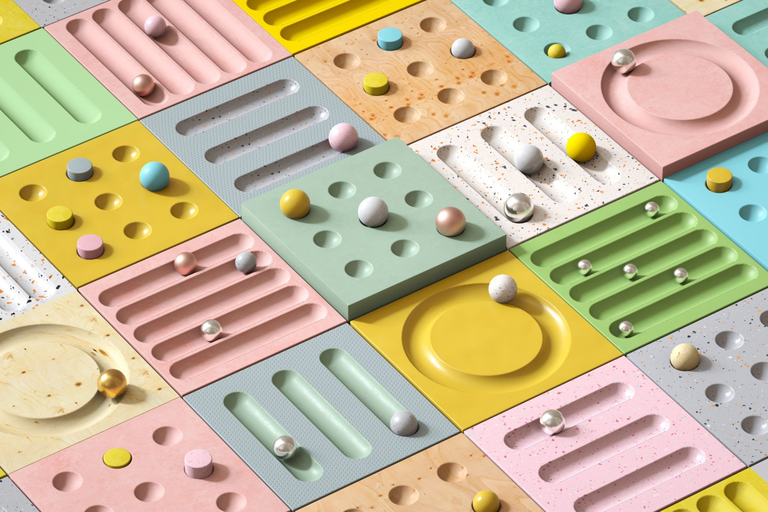

TEST PLAN DOCUMENT

Test plan document for Sauce Demo website

**Test Plan Overview**

1. Introduction
2. Objective
3. Scope
4. Approach
5. Requirement
6. Test Environment
7. Functional testing
8. Inclusion
9. Exclusion
10. Conclusion

**1.INTRODUCTION:**

Sauce Demo is an e-commerce application that allows users to browse the product, add them to a shopping cart and complete the purchase .The purpose of this test plan is to validate the application functionality, usability and compatibility with various browsers.

**2.OBJECTIVE:**

Verify that feature and workflows as expected.

Ensure the application is user friendly with ease of use

confirm compatibility across browsers and devices.

**3.SCOPE :**

The test scope of this website will include:

• Testing of Login page

• Testing of Home page

• Testing of Inventory page

• Testing of Add to Cart Button

• Testing of Checkout Page

**4.Approach:**

The overall testing of the website will be done manually using the black box testing technique. I will validate the login page by filling the details with valid and invalid credentials. Also, I will be exploring the products, adding some of them to cart and the checkout.

**5.Requirements:**

1. A computer with a minimum of 4GB of RAM. 2. A web browser such as Chrome, Firefox or Edge

**6.Test Environment**:

* Windows 10-Chrome
* Firefox
* Edge
* Mac Os
* Safari Browse

**7.Functional test:**

* Product pages (add to cart, view details)
* Shopping cart functionality
* Checkout flow
* Contact forms
* Social media feed integrations (Instagram, TikTok)
* Filter/search functionality.

**1.Usability Testing:**

* Ease of navigation
* Clarity of product information
* Checkout process simplicity
* Mobile responsiveness

**2. Accessibility Testing:**  
Even if the app is technically functional, if users find it difficult to use, they will leave. Good usability improves conversion rates, customer satisfaction, and retention.

**3.Page load times testing:**  
Response times under high traffic  
Load handling during peak hours (e.g., flash sales)

Users expect fast performance. Slow sites result in high bounce rates and lost revenue. Shopify stores, in particular, benefit from performance tuning to stay competitive.

Security breaches damage trust and can lead to legal and financial consequences, especially when handling sensitive customer data.

**8.Inclusion**:

* Login
* Logout
* Navigation
* Product Information
* Filter
* Checkout
* Cart
* Order Confirmation

**9.Exclusion**:.

* Performance
* Security
* Contact
* Account
* Management

**10. Conclusion:**

The test plan document has outlined the testing approach for an sauce demo e-commerce website. After performing the test strategies mentioned, the final product will be assured o

# 

|  |  |  |
| --- | --- | --- |

| SolutionsDocument solutions that were developed  * 1. Solution 1   2. Solution 2   3. Solution 3 |  |  |
| --- | --- | --- |

|  |  |  |
| --- | --- | --- |